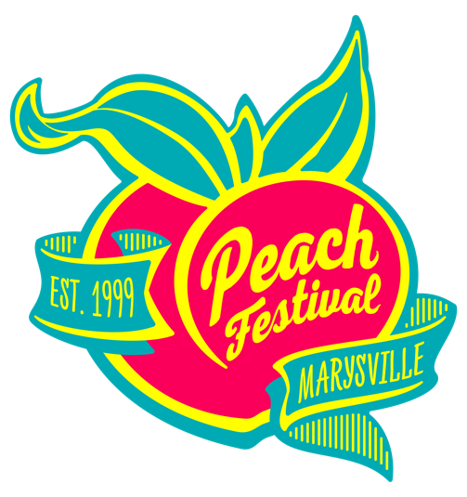
PRESS RELEASE
For Immediate Release
June 13, 2024

24th ANNUAL MARYSVILLE PEACH FESTIVAL SET FOR JULY 19th AND 20th

The 24th Annual Marysville Peach Festival is scheduled for Friday, July 19th from 4 p.m. to 10 p.m. on and Saturday, July 20th from 10 a.m. to 10 p.m. The festival will be held on D Street in Historic Downtown Marysville.
The City of Marysville invites you to come out and enjoy the wide variety of peachy food, two stages of music entertainment, and shop with more than 120 exhibitors alongside more than twenty-five thousand attendees who regularly visit this free community event.
The fun begins on Thursday evening, July 18th when the Marysville Youth Shooting Sports program hosts the Peach Pub Crawl in downtown Marysville from 5:30 – 9:30 p.m. For more information call (530) 682-7160.
New this year, opening night will be kicked off with the Peach Royalty competition hosted through a partnership with the Heartshine Foundation. The competition will take place on the 3rd & D Street Stage from 4 p.m. – 6 p.m. on Friday, July 19th. Categories include: Pre-teen (ages 8-11), Jr. Teen (ages 12-15), Teen (ages 16-18) and Miss (Ages 19-29). To register, visit the Marysville Peach Festival Facebook page and scan the QR code.
The John Sodaro “Onore” award and the Didar Bains “Visionary Leadership” award will be given out on Friday evening between 6:00 – 6:30 p.m. at the 3rd & D Street stage.
Also returning is the 12th annual Peach Festival Tasty Treat Competition hosted by Results Radio. If you think you’ve got the best peach pie recipe or your peach cobbler has the best crumble, enter them into the Tasty Treat Competition. There are both savory and sweet categories and cash prize winners will be announced on Friday evening. For more information call (530) 763-5402.
Returning in 2024 is the Peach Festival 5K Fun Run which will be held on Saturday morning and hosted by The Training Zone. Those interested in registering should contact the Training Zone at (530) 742-7473.
Results Radio will host several games and competitions for several fun prizes at the corner of 3rd & D Streets on Saturday, with the Peach Pie Eating contest happening at high noon.
Introducing this year's newest addition: the Peach Promenade, a vibrant block sponsored by Sutter Health, designed to foster connections and provide a refreshing escape from the summer heat. Located between 3rd and 4th on D Street, the Sutter Health Peach Promenade offers ample seating, umbrella-shaded areas, and strolling entertainers to delight visitors. As night falls, the street will come alive with the warm glow of string lights, creating a magical evening ambiance.
The Marysville Peach Festival is proud to announce a new competition – the 1st Annual Peach Festival Bed Races! Private citizens, civic clubs, families and student groups are encouraged to build a bed to race in the Bed Races, which will take place on D Street between 6th & 7th Street at 11 a.m. on Saturday, July 20th. Winners will receive cash prizes for fastest and best peachy theme.
A children’s entertainment area will be located in the park on the west side of 3rd & D Street with clowns, and musicians entertaining children throughout the day.
There will be something fun for the whole family at the 2024 Marysville Peach Festival.
Street closures to prepare for event set-up begin on Thursday evening, July 18th at 9 p.m.
For information on sponsor and vendor opportunities, contact Sapphire Marketing Group at (530) 763-5402 or visit www.marysvillepeachfest.com.

